Kristin Lindbergh
North Carolina State University
ECI 523 Teacher as Reseacher
11/30/10

Introduction
I earned my AIG Certification in 2008, but have not had an opportunity to really do much with my gifted students in the classroom other than differentiated homework. I have always loved reading and my school has begun to implement a new literacy program this year called Literacy First. I have a few students identified as “gifted” in my classroom this year and I thought this would be the perfect time to try something new with them that I haven’t been able to in the past. This class gave me the motivation to research how using the Think-Tac-Toe strategy would affect my AIG students’ interest and engagement in reading. My research project examined AIG students’ multiple intelligences and what resources and strategies would be best suited for these students. The question I wanted to answer was: “Will integrating Think-Tac-Toes with multiple intelligences promote engagement, as well as an increased interest in reading?” It has been shown that people learn in different ways and multiple intelligences is just one way we can identify student learning styles (Bernard, 2009). My reasons for conducting this research were to try to find out if tailoring a tic-tac-toe board, with after reading activities, towards multiple intelligences would in any way affect a student’s interest and engagement in reading activities. The significance of that would be to confirm that Think-Tac-Toes are a good resource for teachers to use with AIG students to offer them choice and as an extension activity.
Methodology
Students were given a multiple intelligence inventory to determine their strongest multiple intelligence areas. We discussed the results of the inventory so the students would be aware of their areas of strength. I also gave them a reading interest inventory to learn about their reading interests and habits. After determining each student’s strong areas of intelligence and reading interests, students were given Think-Tac-Toes (Appendix 2) to complete while at a Reading Center each week. Each of the activities on the Think-Tac-Toe was from one of the multiple intelligences. For example, students were asked to complete at least two activities from the Think-Tac-Toe after reading a book from a pre-selected assortment of books. The books were related to a theme we were learning about that week and were on different reading levels. I labeled each activity with the initials for one of the multiple intelligences, but did not tell the students what they meant. I did this because I wanted to see if the students would naturally choose an activity that was one of their strengths according to how they answered the multiple intelligence inventory. I also made a rubric (Appendix 1) to assess the students’ completed work. The rubric covers the quality of the work, the students’ work habits and the content of the work the students produce. Each student’s work was graded using the rubric. After completing the activities, I gave the students a short survey (Appendix 3) to find out what they liked/disliked about the activities. The questions included on the survey were:
- Do you feel like you enjoyed the story more because you had to complete the activities? Why or why not?
- What did you think of the activities you had to choose from? Did you like them? Why or why not?
- Why did you choose the activities you did?
- What other activities do you think should be included next time?
I read and analyzed the responses from each student and will use the feedback to create future Think-Tac-Toe activities.
Findings
After analyzing the data, I found that two of the three students naturally chose an activity that represented their stronger multiple intelligence. Both of the students only chose one activity that was one of their strengths, but the other two activities they chose were not ones that they identified as a strength area. The third student only identified one strength area on the inventory, but chose activities that were not within that area. When scoring their work, I found that the quality of work for all three students was a 3/4, work habits were 4/4 and content was 2/4. I felt that I didn’t give enough time to going over the rubric with them and making clear the expectations of what they were being asked to do. I could have also taken the time to create examples of what a 4/4 activity looked like so they would have had an idea of what I was looking for. Each student worked diligently on the activities, but I felt the final product was lacking in content for all three, but the reason for that can go back to the lack of a quality example that should have been provided before they began. I would have liked to see more thought put into responses. I think most of the students only put the minimum into their answers without much explanation. On one student’s response, he/she chose to list vocabulary words he/she found interesting, which was what the activity said to do, but I think it would have been better to ask the student to also tell why they chose the words they did.
I think next time I may try to clearly label what multiple intelligence each activity is and see if that will have any effect on whether or not the student chooses their strength areas more often. I question if the students chose activities they thought would be easier to complete than ones that were within their multiple intelligence. On future Think-Tac-Toe activities, I will label the activities clearly with the intelligence it represents and require students to complete at least one activity within their strength areas. I may also give the multiple intelligence inventory again to see if their views of their strengths have changed.
Students | Activity 1 Intelligence | Activity 2 Intelligence | Activity 3  Intelligence | Rubric Scores
 |  |  |  | Quality | Work Habits | Content
Student A  Musical,  Bodily-Kinesthetic | Write a song to tell the important information from the story. Musical | Draw a picture of your favorite part of the story and label the parts of the picture. Visual - Spatial | List things from the story that are examples of the 5 senses. Nature | 3/4 | 4/4 | 2/4
Student B  Nature, Mathematical,  Verbal – Linguistic | Free Choice | Record at least 5 vocabulary words that you found interesting. Verbal - Linguistic | Create movements for vocabulary words you found from the story. Bodily - Kinesthetic | 3/4 | 4/4 | 2/4
Student C  Logical/Mathematical | List things from the story that are examples of the 5 senses. Nature | Free Choice | List vocabulary from the story on a piece of paper. Intrapersonal | 3/4 | 4/4 | 2/4

Discussion
The implications of my study and findings for my own practice are that it seems like Think-Tac-Toe activities are good resources to use in my classroom. My students seemed to like being able to choose which activity they wanted to complete instead of being told what they had to do. They were able to choose activities that appealed to their multiple intelligence and interests. The implications for others’ practice would be that using Think-Tac-Toes as an extension activity during reading will provide added interest and engagement in the reading process. The students are able to choose from a selection of activities that are examples of all types of multiple intelligence learning styles. Think-Tac-Toes are a good resource for differentiation for all students, and especially for gifted students (Dill, 2010).
After conducting this research project, I have learned there are so many more things I can use in my classroom to differentiate and engage not only my gifted students, but also my other students as well (Kondor, 2007 & Powers, 2008). I have not been fair to all my students by not looking into and trying these ideas sooner. I have learned that my students are eager to try new things and want to be more engaged. I just need to make sure they understand expectations before they get started with something new, so we all can enjoy the experience of trying new things. I have also learned I need to pay more attention to details and put a little more time into planning meaningful activities for my students. If I put more effort and attention into these two areas I will be able to see more students engaged and interested in the Think-Tac-Toes activities and the books they are reading.

References
Bernard, S. (2009, April). How to address multiple intelligences in the classroom. Edutopia, Retrieved from http://www.edutopia.org/multiple-intelligences-immersion-enota-how-to

Dill, M. (2010, February 27). Differentiation in the classroom for gifted students [Online Forum Comment]. Retrieved from http://www.brighthub.com/education/special/articles/65181

Kondor, C. (2007). One size may not fit all, but the right teaching strategies might: the effects of differentiated instruction on the motivation of talented and gifted students. Informally published manuscript, Portland State University, Portland, Oregon. Retrieved from http://www.eric.ed.gov/ERICWebPortal/search/detailmini.jsp?_nfpb=true&_&ERICExtSearch_SearchValue_0=ED497701&ERICExtSearch_SearchType_0=no&accno=ED497701

Powers, E. (2008). The use of independent study as a viable differentiation technique for gifted learners in the regular classroom. Gifted Child Today, 31(3), 57-65.

Wilson, L. (1998, March). What's the big attraction? why teachers are drawn to using multiple intelligences theory in their classrooms. Retrieved from http://www.newhorizons.org/strategies/mi/wilson1.htm

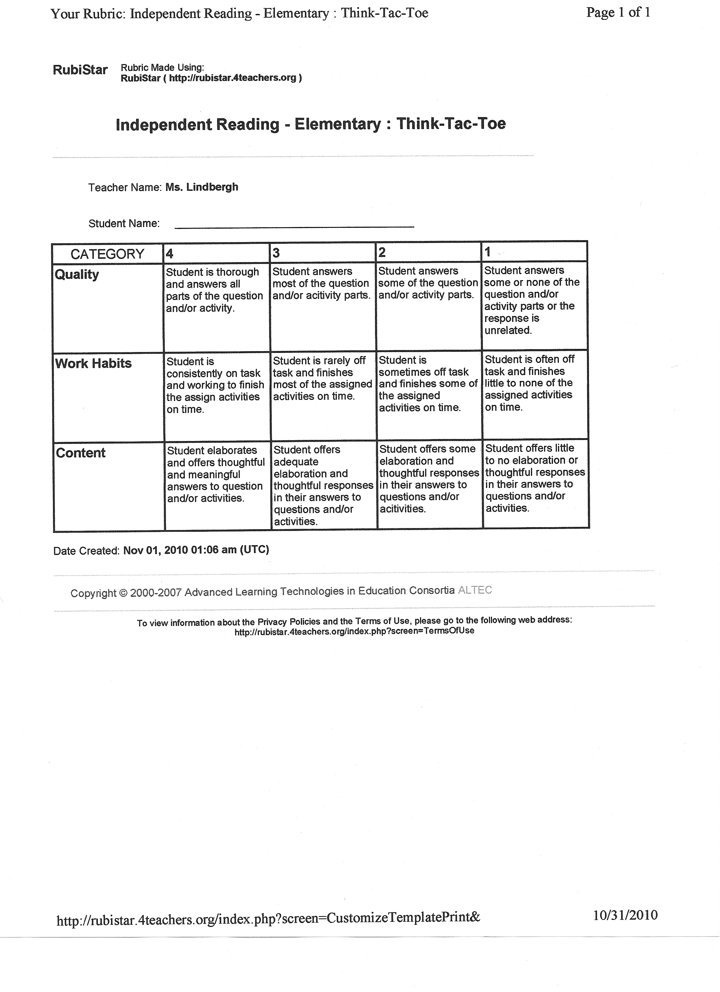
Appendix 1 - Rubricty

Appendix 2 – Sample Think-Tac-Toe
1. V-L  Write a conversation between two characters from your story. | 2. V-S  Research a person or event from the story and make a storyboard to explain your findings. | 3. L-M  Demonstrate an understanding of the information in the text.
4. N  Demonstrate how nature played a role in events from the text. | 5.  FREE CHOICE | 6. B-K  Organize information from the story using a living timeline.
7. INTRA  Interpret and illustrate information from the story on a piece of paper. | 8. INTER  With a partner, create a position statement for a person from the story. (Ex. Emily thinks…) | 9. M  Make up a song to act out a part of the story.
Directions: Choose 3 activities to complete

I chose activities #_____, #_____, #_____.
Appendix 3 – Think-Tac-Toe Survey

Name ________________________________ Date _________________________
Think-Tac-Toe Survey
- Do you feel like you enjoyed the story more because you had to complete the activities? Why or why not?

- What did you think of the activities you had to choose from? Did you like them? Why or why not?

- Why did you choose the activities you did?

- What other activities do you think should be included next time?

